AURAL SUPPORT FOR THE VISUALLY-IMPAIRED

A PROJECT REPORT

*submitted b*y

CB.EN.U4ELC19003 ADITHYA KRISHNAN

CB.EN.U4ELC19005 AGASH UTHAYASURIYAN

CB.EN.U4ELC19016 HEMA CHANDRAN G

**CB.EN.U4ELC19044 SABBINENI HEMA MAHITHA**

***in partial fulfillment for the award of the degree***

of

###### BACHELOR OF TECHNOLOGY

IN

ELECTRICAL AND ELECTRONICS ENGINEERING



**AMRITA SCHOOL OF ENGINEERING, COIMBATORE**

**AMRITA VISHWA VIDYAPEETHAM**

**COIMBATORE- 641112**

**May 2022**

AMRITA VISHWA VIDYAPEETHAM

AMRITA SCHOOL OF ENGINEERING, COIMBATORE, 641112



BONAFIDE CERTIFICATE

This is to certify that the project report entitled, AURAL SUPPORT FOR THE VISUALLY-IMPAIRED submitted by

CB.EN.U4ELC19003 ADITHYA KRISHNAN

CB.EN.U4ELC19005 AGASH UTHAYASURIYAN

CB.EN.U4ELC19016 HEMA CHANDRAN G

**CB.EN.U4ELC19044 SABBINENI HEMA MAHITHA**

in partial fulfillment of the requirements for the award of the degree of **Bachelor of Technology in** **ELECTRICAL & ELECTRONICS ENGINEERING** is a bonafide record of the work carried out under my guidance and supervision at Amrita School of Engineering, Coimbatore.

<< Signature of the Supervisor>>

<< Name>>

SUPERVISOR

<< Designation>>

<< Department>>

<<Signature of the Chairperson >>

<<Name of Chairperson>>

CHAIRPERSON

<< Department>>

This project report was evaluated by us on……….(date)

<<Signature of the Internal examiner with date >>

<<Name>>

INTERNAL EXAMINER  
<<Designation>>

<<Organisation>>

<<Signature of the External examiner with date>>

<<Name>>

EXTERNAL EXAMINER  
<<Designation>>

<<Organisation>>

**ACKNOWLEDGEMENT**

Place: Ettimadai

Date: 08 June 2022

On this great occasion of accomplishment of our project on **Aural Support for Visually Impaired,** we would like to sincerely express our gratitude to all the staff of the **Electrical and Electronics Engineering Department**, who had supported us through the completion of this project.

We are thankful to our Head of Department Dr.Balamurugan S of the Electrical and Electronics Department of Amrita School of Engineering for providing all the required facilities for the completion of this project.

On behalf of my team members, I would like to appreciate the guidance of the faculty and lab in charge who helped us in various ways with their knowledge and helped us complete this project.

Thank You

Adithya Krishnan

(CB.EN.U4ELC19003)

**ABSTRACT**

All living beings see this world through their eyes. For humans books, and documents are the sources of knowledge. But this knowledge is limited to people with visual challenges. For this group of people, the world is like a black illusion. The shape and structural information of an object are unavailable to them let alone reading a document. For the blind, acquiring knowledge by reading documents is cumbersome. Braille is one of the methods which is used to read a book or document. In this method, any document has to be converted to braille format to become understandable to a blind. The problem arises due to the fact that this is an expensive procedure and many times not available. Hence the objective of this project presents an end-to-end cloud system that helps the user to understand the contents of documents/books in an audio format, on the press of a button and also acts as a guiding hand for the user while walking/in rest by detecting the obstacle around them by providing alerts.

**TABLE OF CONTENTS**

|  |  |  |
| --- | --- | --- |
| **CHAPTER** | **TITLE** | **PAGE**  **No** |
|  | LIST OF FIGURES | v |
|  | LIST OF TABLES | vi |
|  | LIST OF SYMBOLS | vii |
|  | LIST OF ABBREVIATIONS | Viii |
| **1** | **INTRODUCTION**   * 1. Objective   2. Why Cloud? | 8  8  8 |
| **2** | **HARDWARE AND SOFTWARE SPECIFICATIONS**   * 1. Hardware components   2. Software components   3. Why Raspberry pi? | 9  9  10  11 |
| **3** | **METHODOLOGY**   * 1. Working principle      1. Text to speech conversion      2. Object detection   3.2 Block Diagram | 13  13  13  14  14 |
| **4** | **SYSTEM DESIGN** | 15 |
| **5** | **REFERENCES** |  |

**LIST OF FIGURES**

|  |  |  |
| --- | --- | --- |
| **Fig.No** | **FIGURE CAPTION** | **PAGE No.** |
| 3.2 | Block Diagram | 14 |
| 4.1 | S3 Service | 15 |
| 4.2 | IAM Users | 15 |
| 4.3 | IAM Roles | 16 |
| 4.4 | IAM Policies | 16 |
| 4.5 | Lambda Function | 16 |
| 4.6 | Lambda Code Source | 17 |
| 4.7 | Cloud Watch Log Group | 17 |
| 4.8 | Cloud Watch Lambda Function | 17 |
| 4.9 | Cloud Watch of Lambda function | 18 |
| 4.10 | Sample Image | 18 |
| 4.11 | Text output in JASON format | 19 |
| 4.12 | Cost of AWS services | 19 |

**LIST OF ABBREVIATIONS**

|  |  |  |
| --- | --- | --- |
| **S.No** | **ABBREVIATION** | **EXPANSION** |
| 1 | GPIO | General Purpose Input Output |
| 2 | HD | High Definition |
| 3 | LED | Light Emitting Diode |
| 4 | AWS | Amazon Web Services |
| 5 | IAM | Identity and Access Management |
| 6 | S3 | Simple Storage Service |
| 7 | gTTS | Google Text To Speech |
| 9 | JASON | JavaScript Object Notation |
| 8 | Wi-Fi | Wireless Fidelity |

**Chapter 1**

**INTRODUCTION**

**1 INTRODUCTION**

The eyes are one of the most important organs of the human body. It is through this organ that people see the world and understand things. It is difficult for a person with the gift of sight to see, understand, and survive in this world. The main problem for them is the inability to read. Without this, visually impaired people feel very hard to understand the contents of books and documents which stops them from obtaining knowledge. Hence our Project aims to aid visually impaired people through the means of technology. This is an IoT-based end-to-end cloud solution that aims to make visually impaired people’s life much easier. This technology is used because the user should be able to use it anywhere, they want and whenever they want. Also, this project intends to build a low power application.

* 1. **Objective**

This project aims to provide an easy way for visually impaired people to understand the contents of books and documents through means of audio. Its aim is also to help them avoid obstacles.

* 1. **Why Cloud?**

As technology is advancing, the amount of data generated and transferred is also increasing. Higher computation needs computers with more advanced components. Hence cloud services were introduced. Data can be stored, managed, and retrieved from anywhere in the world with the right credentials and internet connection. Depending on the demand of the computations and storage requirements, the resources can automatically increase or decrease. Usage of the cloud is more reliable and secure and no need for maintenance is required.

Various cloud services are used to achieve the output of this project.

**Chapter 2**

**HARDWARE AND SOFTWARE SPECIFICATIONS**

**3.1 Hardware Components:**

The hardware requirements of the proposed system are as follows:

1. Raspberry Pi 3B:

Raspberry Pi 3B is a single-board computer that contains a microprocessor along with 40 GPIO pins which can be used by digital and analog sensors to be interfaced with. It supports display output and a camera module connector. It also supports wireless and wired connections to the internet and also has a Bluetooth module to connect with Bluetooth-supported devices. It also has USB ports for pen drives mouse and keyboards

1. Raspberry Pi camera Module:

Raspberry Pi cameras are capable of taking high-resolution photographs, along with full HD 1080p video, and can be fully controlled programmatically.

1. IR sensor:

Infrared sensors, both emit and detect infrared radiation. Active IR sensors have two parts: a light-emitting diode (LED) and a receiver. When an object comes close to the sensor, the infrared light from the LED reflects off of the object and is detected by the receiver. Through this, any object within the range of can be detected and it operates on negative logic and outputs the value that is inverse if the output is needed.

1. Earphone:

An earphone is attached to the 3.5mm jack of the Raspberry Pi to deliver the audio information to the user.

**3.2 Software Components:**

1. AWS:

Amazon web service is an online platform that provides scalable and cost-effective cloud computing solutions. AWS is a broadly adopted cloud platform that offers several on-demand operations like compute power, database storage, content delivery, etc., to help corporates scale and grow. Data can be stored, managed, and retrieved from anywhere in the world with the right credentials and internet connection. Depending on the demand of the computations and storage requirements, the resources can automatically increase or decrease. Usage of the cloud is more reliable and secure and no need for maintenance is required.

1. IAM - Identity and Access Management:

AWS Identity and Access Management (IAM) provides fine-grained access control for the users across all AWS services. With IAM, you can specify who can access which services and resources, and under which conditions. With IAM policies, the administrator can manage permissions to their workforce and systems to ensure the least privileged permissions.

1. S3 – Simple Storage Service:

Amazon Simple Storage Service (Amazon S3) is an object storage service that offers industry-leading scalability, data availability, security, and performance. You can use Amazon S3 to store and retrieve any amount of data at any time, from anywhere.

1. Lambda:

Lambda is a serverless compute. A user-defined code can be executed based on the response of events in AWS services such as adding/removing files in the S3 bucket, updating Amazon DynamoDB tables, HTTP requests from Amazon API Gateway, etc.

1. Textract:

Amazon Textract is a machine learning (ML) service that automatically extracts text, handwriting, and data from scanned documents using the Amazon Textract Document Analysis API. It goes beyond simple optical character recognition (OCR) to identify, understand, and extract data from forms and tables. With Amazon Textract, users only pay for the documents that they analyze. It can extract text in harsh conditions also like images with low light or images with noises

1. CloudWatch:

Amazon CloudWatch allows the user to collect, access, and correlate data on a single platform from across all their AWS resources, applications, and services running on AWS and on-premises. This helps the user to gain system-wide visibility which allows the user to identify and resolve issues quickly.

1. gTTS - Google Text-to-Speech:

gTTS (Google Text-to-Speech) is a Python library and CLI tool to interface with Google Translate text-to-speech API. We will import the gTTS library from the gTTS module which can be used for speech translation. The text variable is a string used to store the user's input.

1. Pygame

Pygame library is an open-source module for the Python programming language specifically intended to help you make games and other multimedia applications. Here it is used to play the audio file through a python script.

**3.1 Why Raspberry PI?:**

Raspberry Pi 3B is a single-board computer that contains a microprocessor along with 40 GPIO pins which can be used by digital and analog sensors to be interfaced with. It supports display output and a camera module connector. It also supports wireless and wired connections to the internet and also has a Bluetooth module to connect with Bluetooth-supported devices. It also has USB ports for pen drives mouse and keyboards.

The facility of supporting different types of OS is a huge advantage. The presence of USB, Ethernet port, and a Wi-Fi module and display output makes it a mini portable computer with the need for low power for working. In the field of IoT, it is capable of doing multiple tasks at a time like a computer. Any complex project can be built with it.

Unlike other IoT facilitating microcontroller boards, the presence and combination of OS and network connectivity options like built-in Ethernet and Wi-Fi module make the Raspberry Pi a very powerful IoT device, due to which it can be configured into a web server, VPN server, print server, database server, etc.

Raspberry Pi uses an SD card as flash memory to install OS. Hence it is flexible in deciding the amount of storage for the project. Due to this, the OS can be easily changed just by swapping the SD cards.

* + 1. Other Raspberry pi models
* Pi 1 Model B
* Pi 1 Model A
* Pi 1 Model B+
* Pi 1 Model A+
* Pi 2 Model B
* Pi Zero
* Pi 3 Model B
* Pi Zero W
* Pi 3 Model B+
* Pi 3 Model A+
* Pi 4 Model A
* Pi 4 Model B

Raspberry Pi 3 Model B was chosen for this project because the previous versions did not have a Wi-Fi module and the Wi-Fi module was necessary for this project. Also, the high computational power of the next generation of Pi 3 model B was not necessary.

**Chapter 3**

**METHODOLOGY**

**3.1 Working Principle**

**3.1.1 Text to Speech Conversion**

1. A camera module is attached to the Raspberry PI 3 microprocessor, which is used to capture the image or the pages of a book or a document that is to be converted into audio
2. A python library called BOTO3 is used to connect the python script to the AWS account with the appropriate credentials. AWS IAM service is used to create policies for the administration purpose of S3 bucket access.
3. The captured image of the document or book is sent to the AWS cloud and is stored in the S3 storage service using the BOTO3 library in python. The action of storage of the image into the bucket triggers the lambda function which transfers the newly uploaded image to an AWS service called ‘textract’.
4. Textract is an AWS service that is an image-to-text converter service. This automatically selects the best hyper parameter for image-to-text conversion and hence gives very high accuracy. This hyper parameter is a term used in machine learning to determine the learning involved. This learning can be either supervised or unsupervised, and can be changed according to user’s choice
5. The output of the textract service is stored in an S3 bucket in form of JASON file. This triggers a lambda function which sends the extracted text from S3 to the Raspberry pi
6. The gTTS (Google Text to Speech) module in python is used to convert the text into an audio file which is saved in the Raspberry pi. A module called pygame is used as an audio player in python scripts with which the audio file can be played. The output can be heard through an earphone that is connected to the Audio jack port of the Raspberry PI

**3.1.2 Object detection**

1. An IR sensor is connected to the Raspberry Pi with its GPIO pins, and is used to detect any object in its line of sight. If an object is detected within its range of detection the IR sensor lights up. According to it, an audio message is sent to the user through the earphone connected to the audio jack of the Raspberry Pi

**3.2 Block Digram**

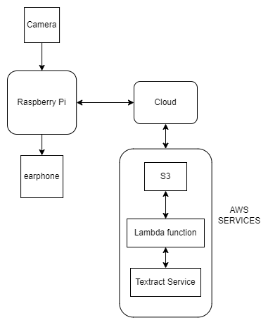

**Chapter 4**

**SYSTEM DESIGN**

S3 Service

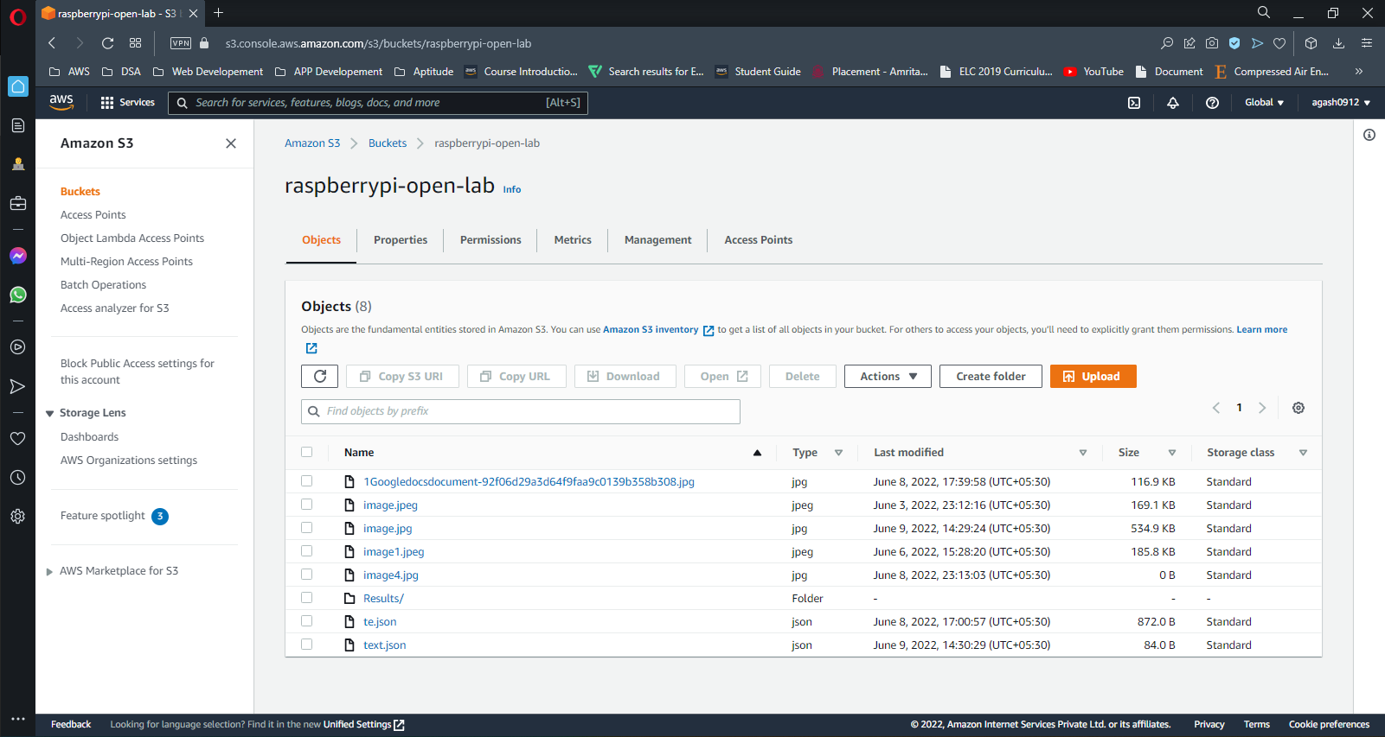

***Fig 4.1*** *S3 Service*

Amazon S3 is an object-oriented storage service. Here the image uploaded from the Raspberry pi module is stored and the converted text which will be in JSON format is stored here.

IAM Users

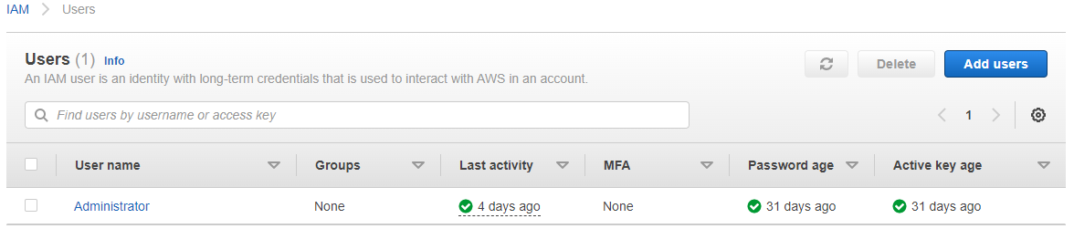

***Fig 4.2*** *IAM Users*

A user in AWS consists of a name and credentials. Here Administrator is the root user that is used to access manage and configure the AWS services and resources associated with this AWS account.

IAM Roles

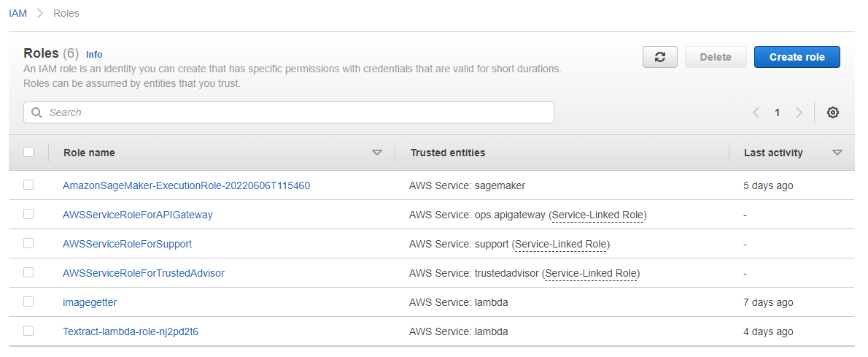

***Fig 4.3*** *IAM Roles*

IAM Policies

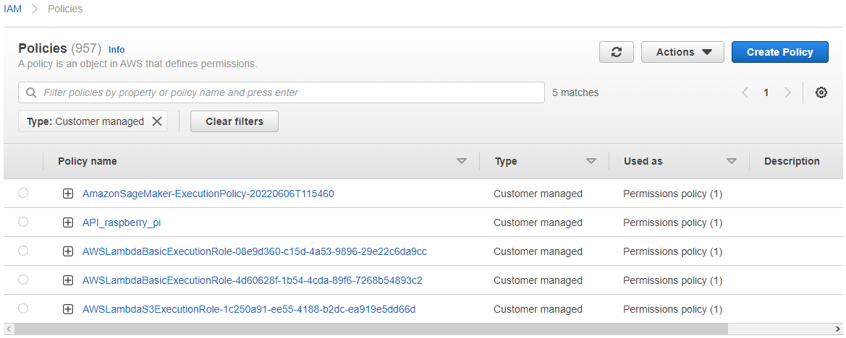

***Fig 4.4*** *IAM Policies*

Lambda

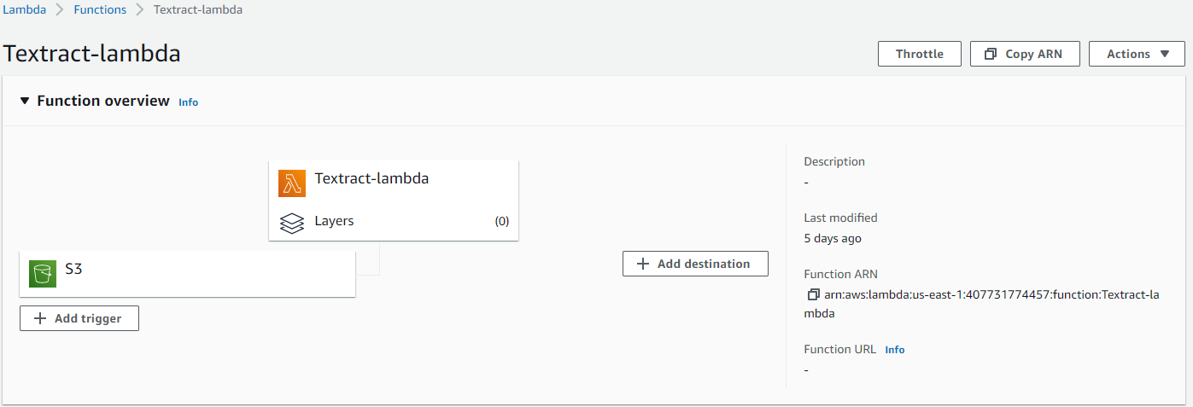

***Fig 4.5*** *Lambda Function*

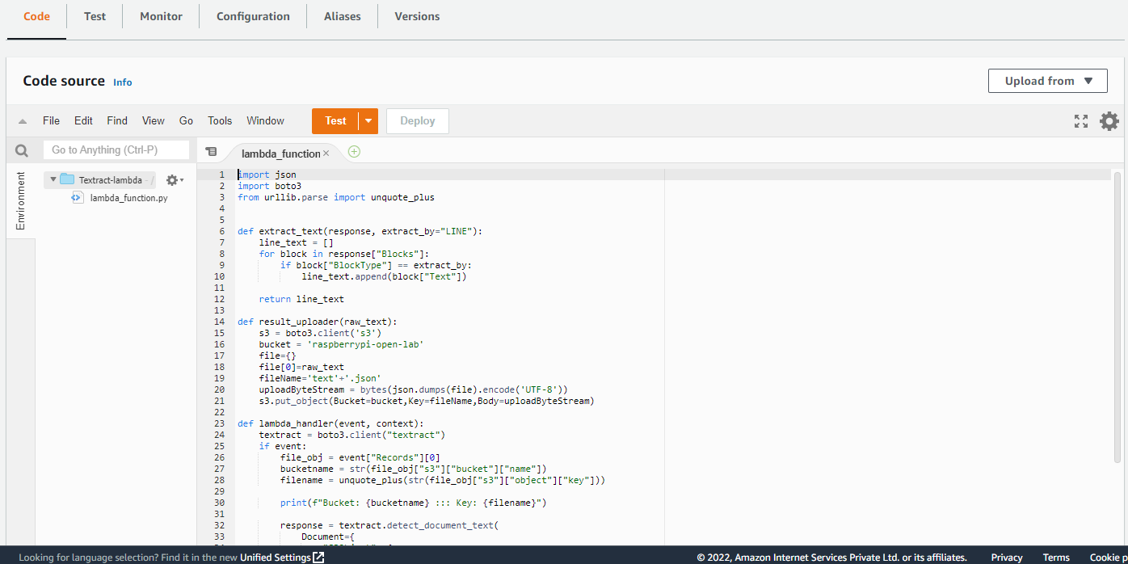

***Fig 4.6*** *Lambda Code Source*

Cloud Watch

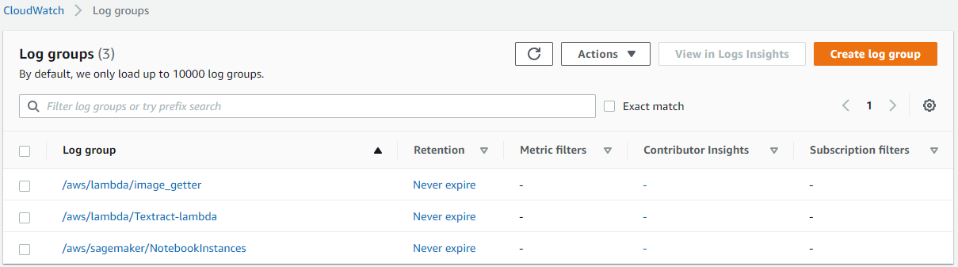

***Fig 4.7*** *Cloud Watch Log groups*

Cloud Watch of Lambda function

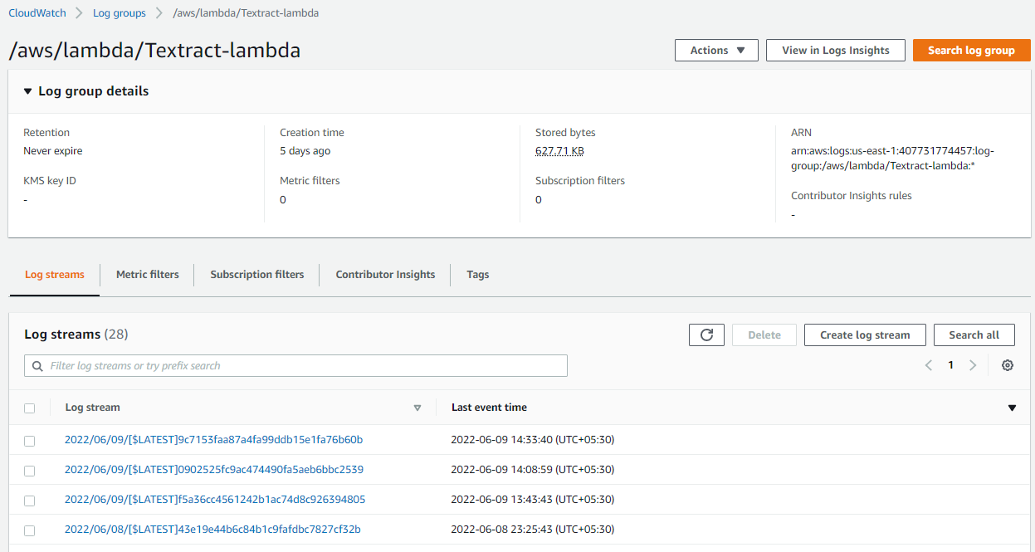

***Fig 4.8*** *Cloud Watch of Lambda function*

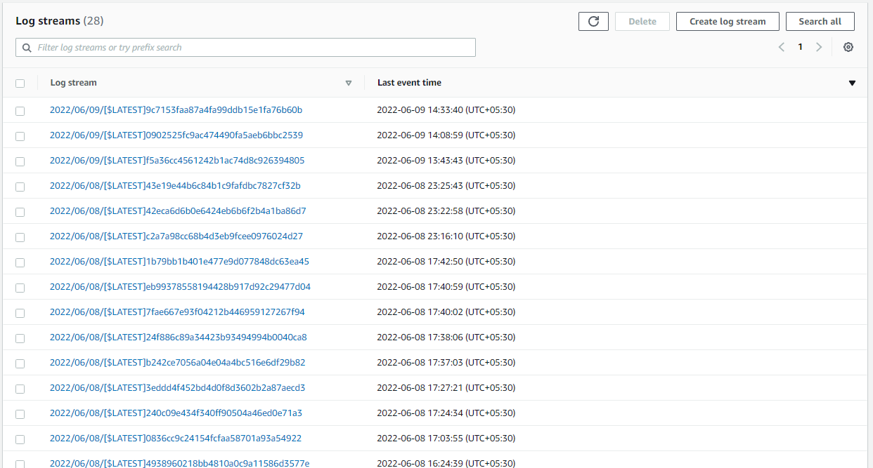

***Fig 4.9*** *Cloud Watch of Lambda function*

Figure 4.7 and 4.8 shows all log streams of the lambda function

Sample image with text

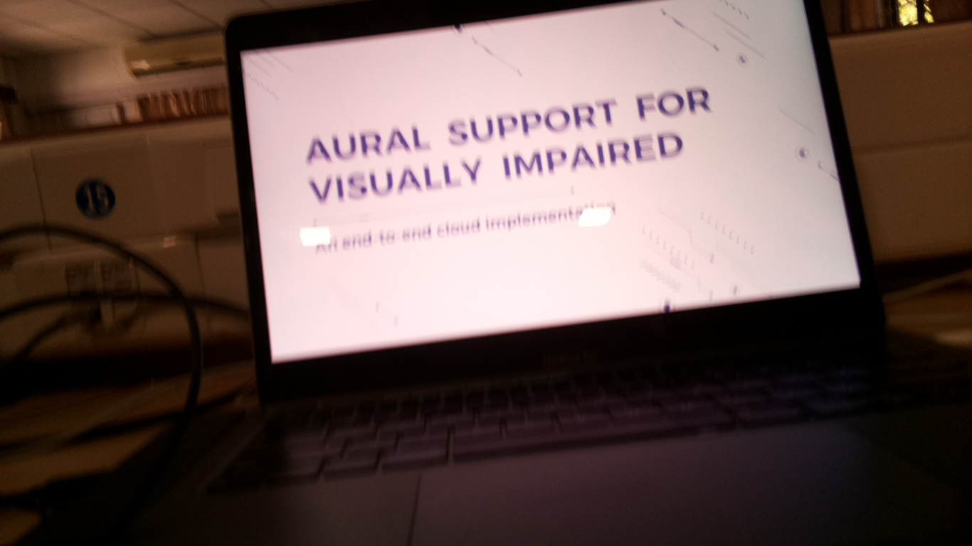

***Fig 4.10*** *Sample Image*

Text Output in JASON format

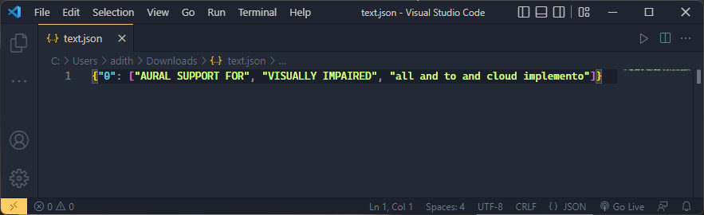

***Fig 4.11*** *Text output in JASON format*

The total cost of the Amazon Web Services is 0$

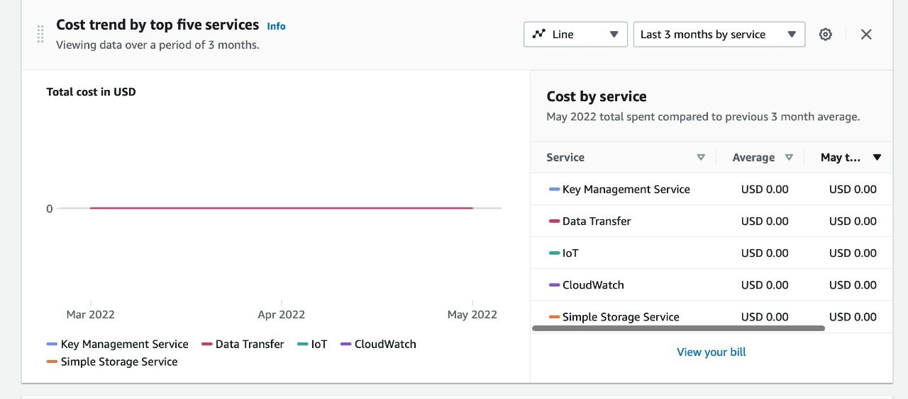

***Fig 4.11*** *Cost of AWS services*

**REFERENCES**

1. Botta, Alessio & Donato, Walter & Persico, Valerio & Pescapè, Antonio. (2015). Integration of Cloud computing and Internet of Things: A survey. Future Generation Computer Systems. 56. 10.1016/j.future.2015.09.021.

Available: <https://www.researchgate.net/publication/283236612_Integration_of_Cloud_computing_and_Internet_of_Things_A_survey>

1. Pourqasem, J. (2018). 'Cloud-based IoT: integration cloud computing with internet of things', International Journal of Research in Industrial Engineering, 7(4), pp. 482-494. doi: 10.22105/riej.2018.88380

Available:

<http://www.riejournal.com/article_88380.html>

1. Al Dahoud, Ali & Fezari, Mohamed. (2019). Use a Raspberry Pi and Amazon AWS For IoT Application Developement.

Avaialble:

<https://www.researchgate.net/publication/334825592_Use_a_Raspberry_Pi_and_Amazon_AWS_For_IoT_Application_Developement>